Peter Victoratos

CSC 411

April 17, 2018

**Lab 18 Pre-trained CNN**

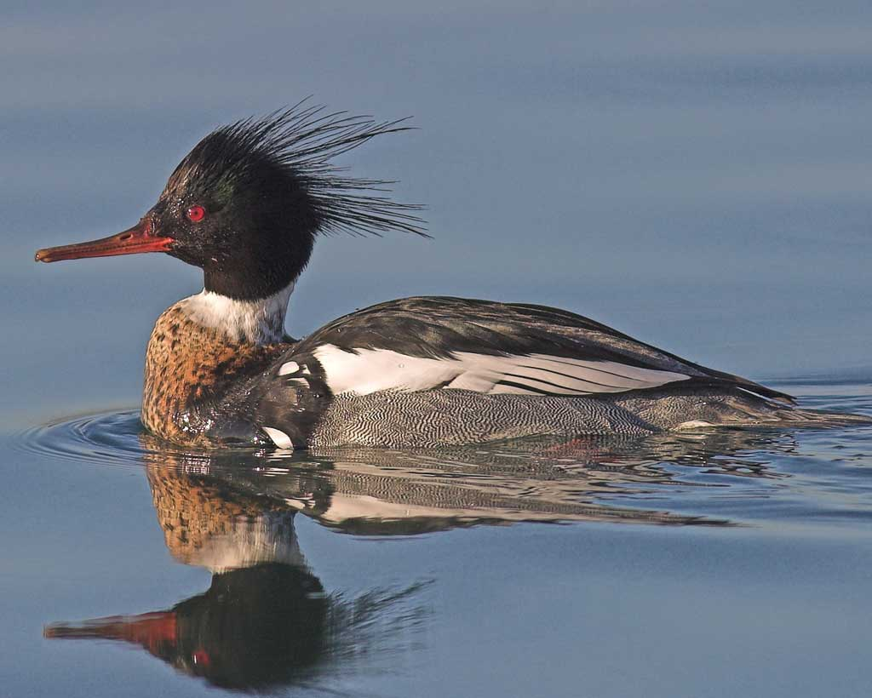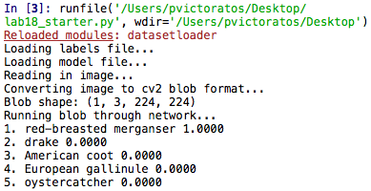

Trials with an image of a red-breasted merganser and a groom from online

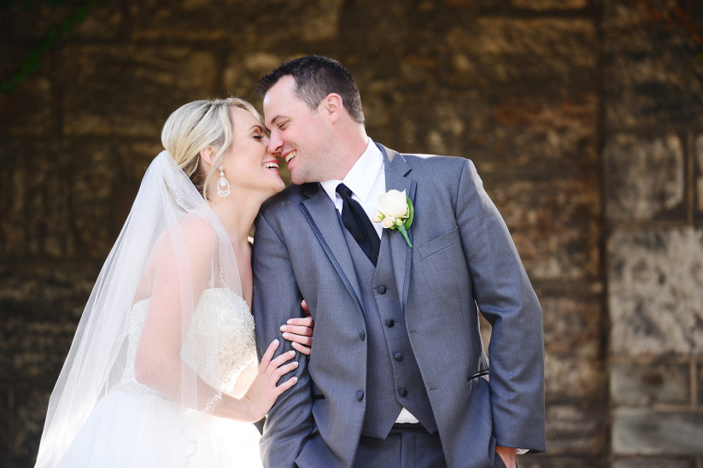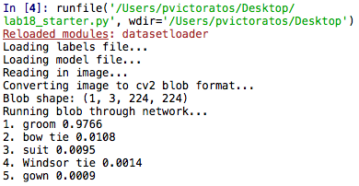

I then adapted some of the code from labs 15-17 to have it loop through my animals dataset. It then classifies the images using our labels.